CH. 5 Periodic Trends
Elemental Properties/Patterns
The Periodic Law
Dimitri Mendeleev was the first scientist to publish an organized periodic table of the known elements.
He was perpetually in trouble with the Russian government and the Russian Orthodox Church, but he was brilliant never-the-less.
Mendeleev ordered elements by atomic mass and found “repeating” patterns of properties.
He even went out on a limb and predicted the properties of 2 (at the time) undiscovered elements.
Mendeleev was very accurate in his predictions, which led the world to accept his ideas about periodicity and a logical periodic table.
Later, Henry Mosely revised the ‘Periodic Law’ which states:
When arranged by increasing atomic number, the chemical elements display a regular and repeating pattern of chemical and physical properties.
Electron Configurations
Write out the full electron configurations for the group 1A elements. You will find a repeating pattern.
H:
Li:
Na:
K:
Rb:
Cs:
Fr:
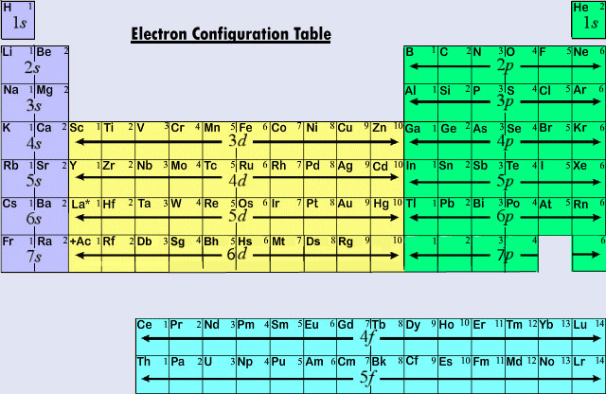
Atoms with similar properties appear in groups or families (vertical columns) on the periodic table.
They are similar because they all have the same number of valence (outer shell, s and p) electrons, which governs their chemical behavior.
A different type of grouping
Besides the 4 blocks of the table, there is another way of classifying element:
Metals
Nonmetals
Metalloids or Semi-metals.
The following slide shows where each group is found.

Metals, Nonmetals, Metalloids
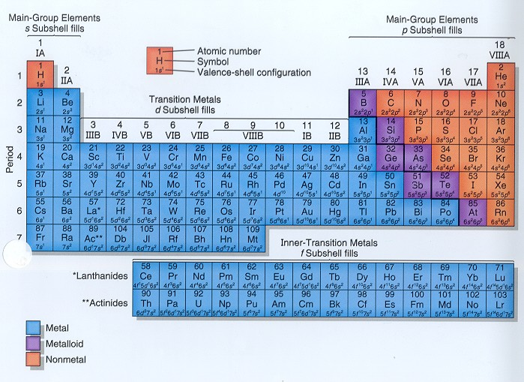
There is a zig-zag or staircase line that divides the table.
Metals are on the left of the line.
Nonmetals are on the right of the line.
Elements that border the stair case, shown in purple are the metalloids or semi-metals.
Except Aluminum is more metallic than not.

Periodic Trends
There are several important atomic characteristics that show predictable trends that you should know.
The first and most important is atomic radius.
Radius is the distance from the center of the nucleus to the “edge” of the electron cloud.
Atomic Radius
Since a cloud’s edge is difficult to define, scientists use define covalent radius, or half the distance between the nuclei of 2 bonded atoms.
Atomic radii are usually measured in picometers (pm) or angstroms (Å). An angstrom is 1 x 10⁻¹⁰ m.
Covalent Radius
Two Br atoms bonded together are 2.86 angstroms apart. So, the radius of each atom is 1.43 Å.
2.86 Å
1.43 Å
1.43 Å

Atomic Radius: TREND
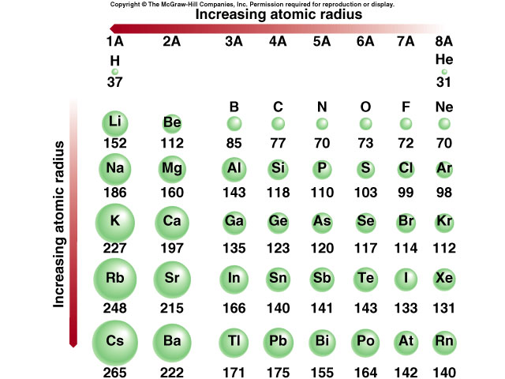

The trend for atomic radius: DECREASES up in a family (vertical column) and across a period (left to right).
WHY??
Effective Nuclear Charge
What keeps electrons from simply flying off into space?
Effective nuclear charge is the pull that an electron “feels” from the nucleus.
The closer an electron is to the nucleus, the more pull it feels.
As effective nuclear charge increases, the electron cloud is pulled in tighter.
Ionization Energy
This is the second important periodic trend.
If an electron is given enough energy to overcome the effective nuclear charge holding the electron in the cloud, it can leave the atom completely.
The atom has been “ionized” or positively charged.
The energy required to remove an electron from an atom is ionization energy. (measured in kilojoules, kJ)
The larger the atom is, the easier its electrons are to remove.
**Ionization energy and atomic radius are inversely proportional.
Ionization energy is always endothermic, that is energy is added to the atom to remove the electron.
Ionization Energy: TREND
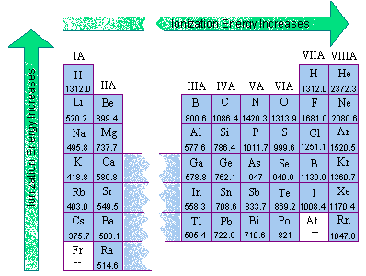
The trend for ionization energy: INCREASES up in a family (vertical column) and across a period (left to right).
Electron Affinity
What does the word ‘affinity’ mean?
Electron affinity is the energy change that occurs when an atom gains an electron (also measured in kJ).
Where ionization energy is always endothermic, electron affinity is usually exothermic, but not always.

Electron Affinity: TREND
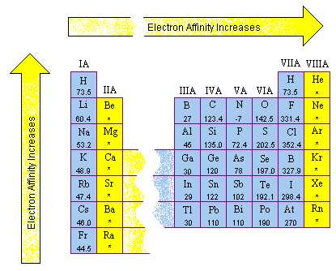
The trend for Electron Affinity: INCREASES up in a family (vertical column) and across a period (left to right) EXCEPT NOBLE GASES, meaning atom WANTS an electron.
Electronegativity
Electronegativity is a measure of an atom’s attraction for another atom’s electrons.
(It is an arbitrary scale that ranges from 0 to 4).
***Generally, metals are electron givers and have low electronegativities.
***Nonmetals are are electron takers and have high electronegativities.
What about the noble gases?
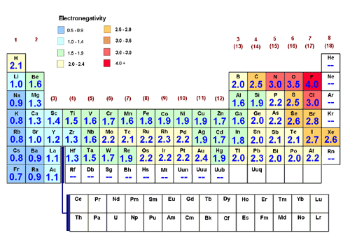
Summary of Trends
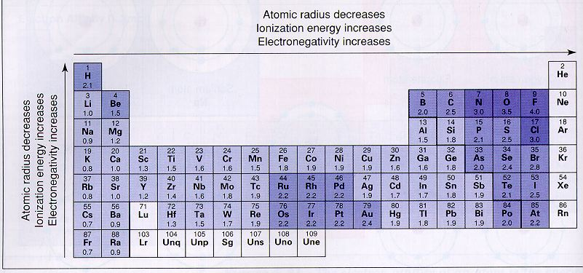
Ionic Radius
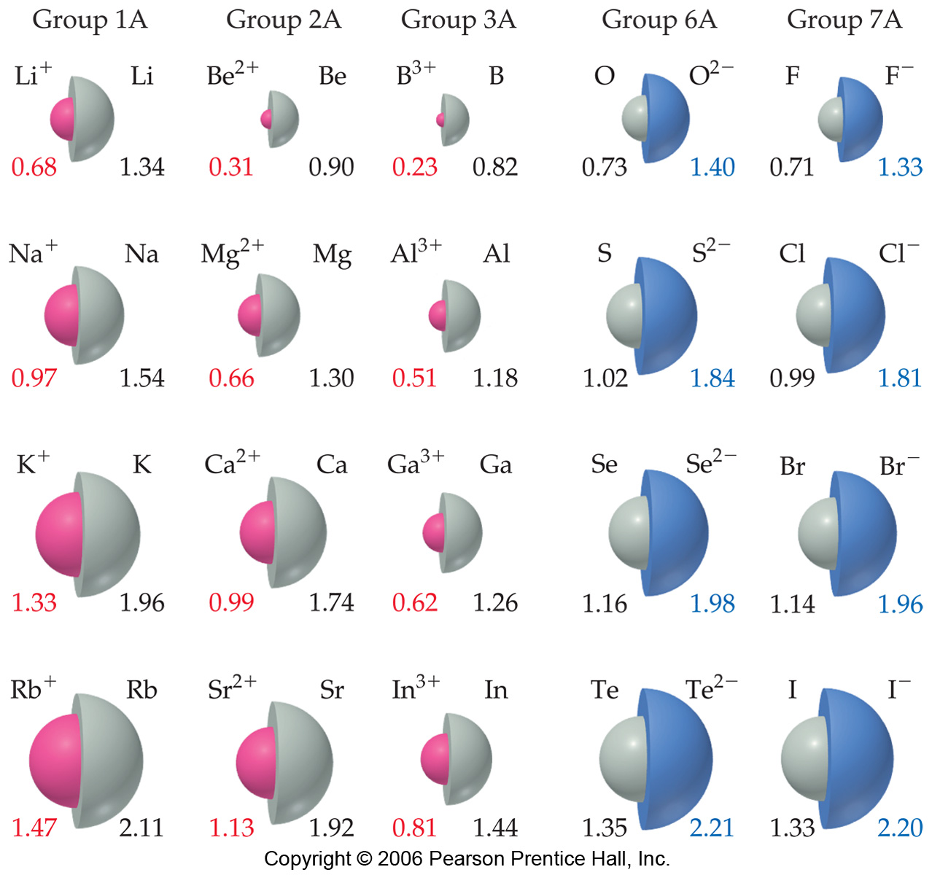
POSITIVE IONS are always smaller than the original atom.
Conversely, NEGATIVE IONS are always larger than the original atom.

