Ch. 6 & 7: Chemical Bonding
I: Introduction to Bonding (pg. 161-163)
Vocabulary
Chemical Bond
- attractive force between atoms or ions that binds them together as a unit
- bonds form in order to…
  - decrease potential energy (PE)
  - increase stability
Chemical Formula
Ionic Covalent

Formula Molecular
Unit Formula
NaCl CO₂

Compound
2 elements more than 2 elements

Binary Ternary
Compound Compound
NaCl NaNO₃
Ion
1 atom 2 or more atoms

Monotomic Polyatomic
Ion Ion
Na⁺ NO₃⁻
Types of Bonds
 | Ionic | Covalent
Bond Formation | e⁻ are transferred from metal to nonmetal | e⁻ are shared between two nonmetals
Type of Structure | Crystal lattice | True molecules
Physical State | Solid | Liquid or gas
Melting Point | High | Low
Solubility in Water | Yes | Usually not
Electrical Conductivity | Yes  (solution or liquid) | No
Other Properties |  | Odorous

 | Metallic
Bond Formation | e⁻ are delocalized among metal atoms
Type of Structure | “electron sea”
Physical State | Solid
Melting Point | Very high
Solubility in Water | No
Electrical Conductivity | Yes (any form)
Other Properties | Malleable, ductile, lustrous

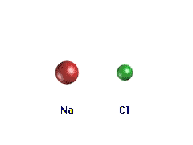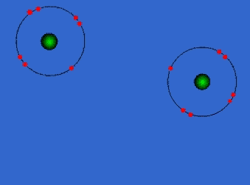
Ionic Bonding-Crystal Lattice
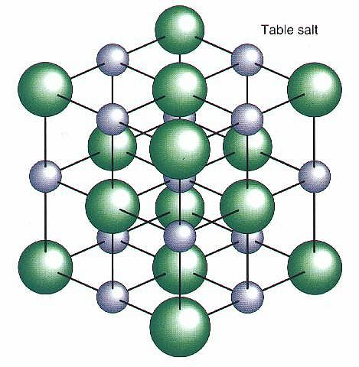
Covalent Bonding-True Molecules
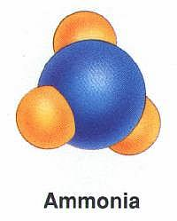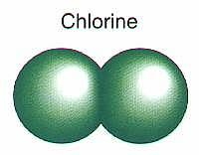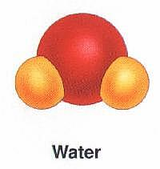
Diatomic Molecule
Metallic Bonding-“Electron sea”
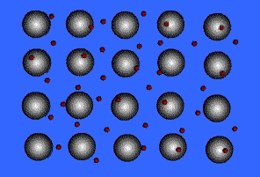

Bond polarity
- Most bonds are a blend of ionic and covalent characteristics.
- Difference in electronegativity determines bond type.
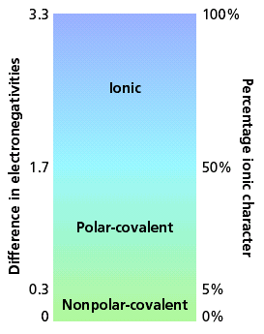
Electronegativity
- Attraction an atom has for a shared pair of electrons.
- higher e⁻neg atom ⇒ δ⁻
- lower e⁻neg atom⇒ δ⁺
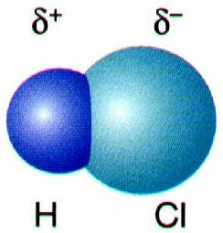

Electronegativity Trend (p. 151)
- Increases up and to the right.

Nonpolar Covalent Bond
- e⁻ are shared equally
- symmetrical e⁻ density
- usually identical atoms
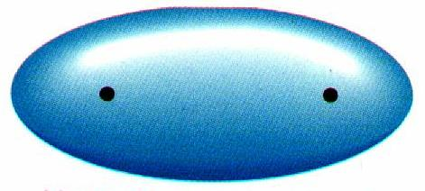

Polar Covalent Bond
- e⁻ are shared unequally
- asymmetrical e⁻ density
- results in partial charges (dipole)
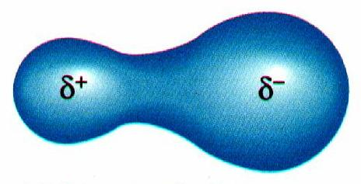
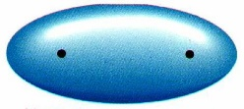
Nonpolar

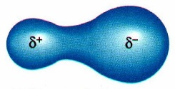
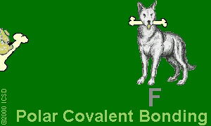
Polar

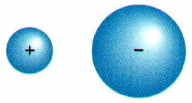
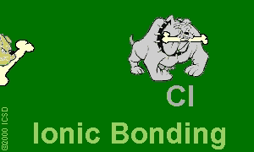
Ionic

Examples:
Cl₂ 3.0-3.0=0.0
Nonpolar
HCl 3.0-2.1=0.9
Polar
NaCl 3.0-0.9=2.1
Ionic

