Ch. 6 & 7 - Chemical Bonding
II. Molecular Compounds
(p. 164 – 172, 211 – 213)
Energy of Bond Formation
Potential Energy
- based on position of an object
- low PE = high stability
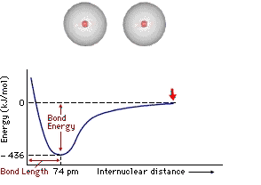

Potential Energy Diagram 1 (Label the diagram)
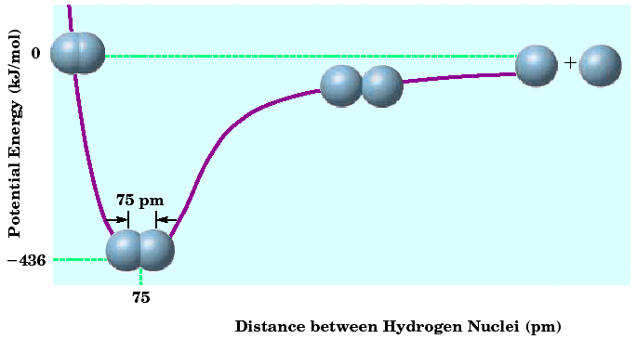
Potential Energy Diagram 2 (Label the diagram!)

Bond Energy (Label the diagram!)
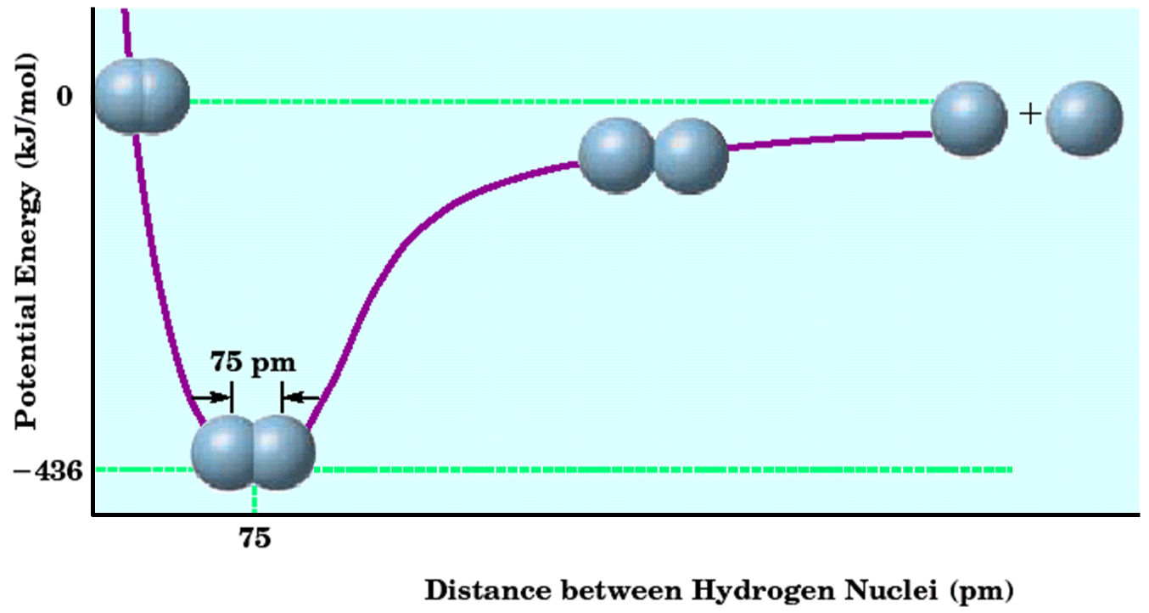

Bond Energy
Short bond = high bond energy
Lewis Structures
Electron Dot Diagrams (Draw the pictures on this slide!)
- show valence e⁻ as dots
- distribute dots like arrows
in an orbital diagram
- 4 sides = 1 s-orbital, 3 p-orbitals
  - EX: oxygen
Octet Rule (Draw the picture on this slide!)
- Most atoms form bonds in order to obtain 8 valence e⁻
- Full energy level stability ~ Noble Gases
Nonpolar Covalent - no charges
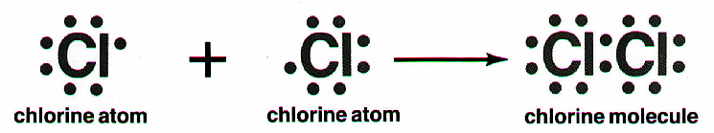

Polar Covalent - partial charges
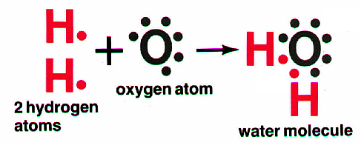
Molecular Nomenclatures (naming covalent molecules)
Prefix System (binary compounds)
- Less e⁻neg atom comes first.
- Add prefixes to indicate # of atoms. Omit mono- prefix on first element.
- Change the ending of the second element to -ide.
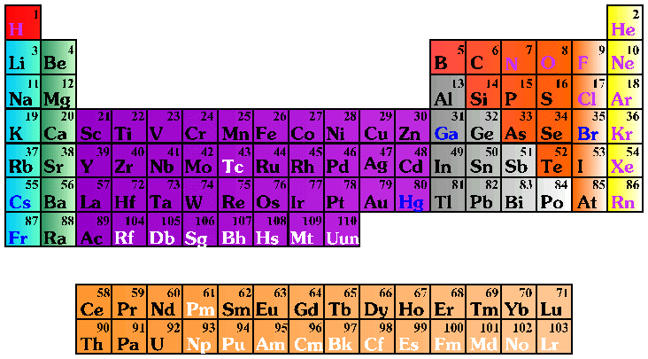

PREFIX | NUMBER
Mono- | 1
Di- | 2
Tri- | 3
Tetra- | 4
Penta- | 5
Hexa- | 6
Septa- | 7
Octa- | 8
Nona- | 9
Deca- | 10

CCl₄ Carbon tetrachloride N₂O Dinitrogen monoxide
SF₆ Sulfur hexafluoride

arsenic trichloride AsCl₃ dinitrogen pentoxide N₂O₅
tetraphosphorus decoxide P₄O₁₀

The Seven Diatomic Elements
Br₂ I₂ N₂ Cl₂ H₂ O₂ F₂

Ch. 6 & 7 - Chemical Bonding
III. Ionic Compounds
(p. 176 – 180, 203 – 211)
Energy of Bond Formation
Lattice Energy
- Energy released when one mole of an ionic crystalline compound is formed from gaseous ions
Lewis Structures
- Covalent – show sharing of e⁻
- Ionic – show transfer of e⁻
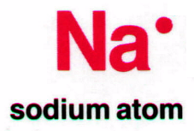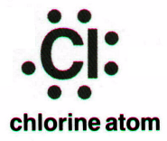

Ionic Nomenclature (Naming Ionic compounds)
Ionic Formulas
- Write each ion, cation first. Don’t show charges in the final formula.
- Overall charge must equal zero.

  - If charges cancel, just write symbols.
  - If not, use subscripts to balance charges.

- Use parentheses to show more than one polyatomic ion.
- Stock System - Roman numerals indicate the ion’s charge.
Ionic Names
- Write the names of both ions, cation first.
- Change ending of monatomic ions to -ide.
- Polyatomic ions have special names.
- Stock System - Use Roman numerals to show the ion’s charge if more than one is possible. Overall charge must equal zero.

- Consider the following:

  - Does it contain a polyatomic ion?
  - -ide, 2 elements ⇒ no
  - -ate, -ite, 3+ elements ⇒ yes
  - Does it contain a Roman numeral?
  - Check the table for metals not in Groups 1 or 2.
  - No prefixes!

Common Ion Charges
(Label the picture with the charge!)
potassium chloride
K⁺ + Cl⁻ ⇒ KCl
magnesium nitrate
Mg²⁺ ⁺ NO₃⁻ ⇒ Mg(NO₃)₂
copper(II) chloride
Cu²⁺ ⁺ Cl⁻ ⇒ CuCl₂

NaBr Sodium bromide Na₂CO₃ Sodium carbonate
FeCl₃ Iron (III) chloride

